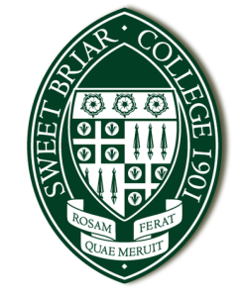
Financial Aid
434.381.6156 |  434.381.6450 | financialaid@sbc.edu
2025-2026 Statement of Non-Filing Status
Please print, sign and submit this form along with all additional required documentation to the Office of Financial Aid.

Complete this form if you, your parent(s), and/or your spouse did not and were not required to file a 2023 federal income tax return (or foreign return). You must also attach copies of W-2 forms from all employers. Replacement copies of W-2’s may be obtained from your employer or by requesting a Wage and Income Transcript from the IRS (www.irs.gov)

Student Name _______________________________________ | Student ID ______________________
Section A – Student and/or Student’s Spouse Statement of Non-Filing Status
Were you (the student) employed at any time during 2023? |  Yes No
Was your spouse employed at the time during 2023? |  Yes No I am not married

If you, or your spouse, were employed in 2023 and did not file a tax return, list the income received from all employers (even if a W-2 was not issued). Please attach copies of all W-2’s.

Name of Non-Filer | Employer of Source of Income | 2023 Income | W-2 Attached
 |  |  | Yes No
 |  |  | Yes No
 |  |  | Yes No

I/we certify that I/we did not and were not required to file a 2023 Federal income tax return or foreign tax return and that all of the information reported is complete and accurate.

____________________________________________ _____________________________________________
Student’s Signature Date Spouse’s Signature Date

